**Statistical Machine Learning Approaches to Liver Disease Prediction**

**Team ID: PNT2022TIMD08311**

**Faculty Mentor:** **Team Leader :** Kavuri Swathi

T.Geetha **Team Member :** Jasthi Jyothi

**Team Member :** Karumudi Meghana

**Team Member :** Biridepalli Mounisha

**Data Pre-Processing**

Data Pre-processing includes the following main tasks

1. Import the Libraries.
2. Reading the dataset.
3. Analyse the data.
4. Taking Care of Missing data.
5. Data Visualization.
6. Splitting the Dataset into Dependent and Independent variables.
7. Splitting Data into Train and Test

**Importing The Libraries**

The first step is usually importing the libraries that will be needed in the program.

The required libraries to be imported to  Python script are:

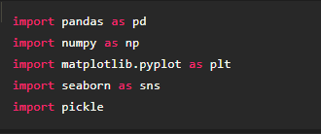

**Numpy:**

It is an open-source numerical Python library. It contains a multi-

dimensional array and matrix data structures. It can be used to perform

mathematical operations on arrays such as trigonometric, statistical, and

algebraic routines.

Example:

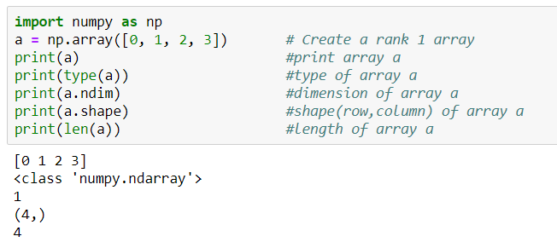

**Pandas:**

It is a fast, powerful, flexible and easy to use open source data analysis and

manipulation tool, built on top of the Python programming language.

Example:

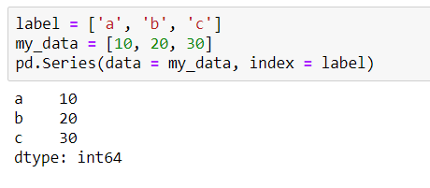

**Matplotlib:**

Visualisation with python. It is a comprehensive library for creating static,

animated, and interactive visualizations in Python.

Example:

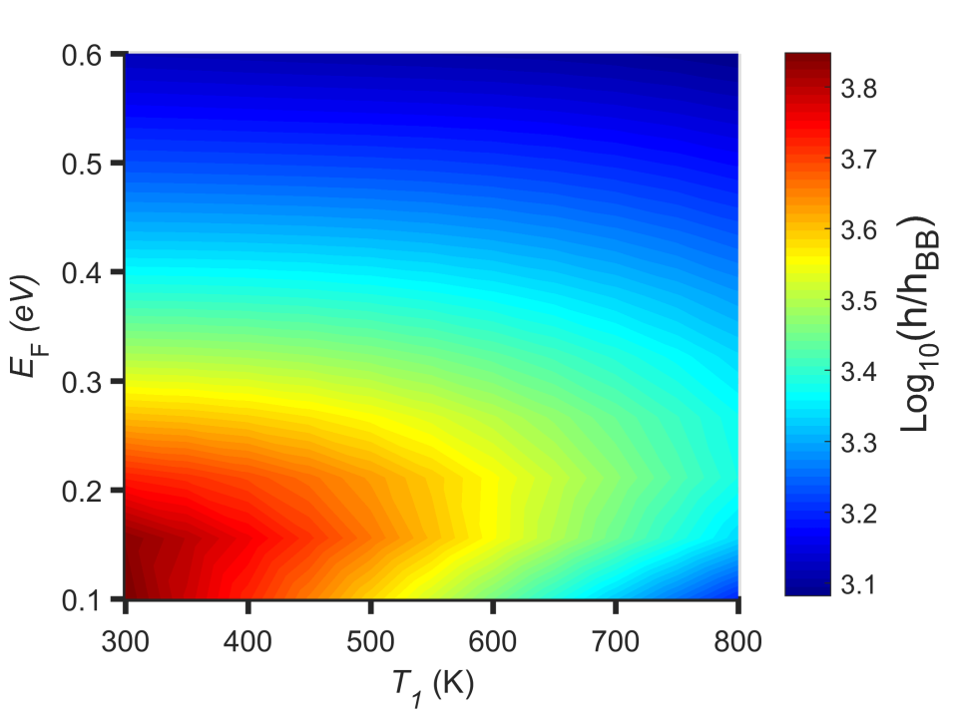

**Seaborn:**

Seaborn is a library for making statistical graphics in Python. Seaborn helps

you explore and understand your data. Its plotting functions operate on

dataFrames and arrays containing whole datasets and internally perform the

necessary semantic mapping and statistical aggregation to produce

informative plots.

Example:

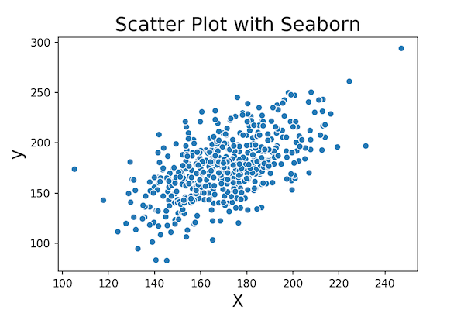

**Pickle:**

The pickle module implements serialization protocol, which provides an

ability to save and later load Python objects using special binary format.